**PRE-REQUISITES**

|  |  |
| --- | --- |
| **Project Title** | SmartFarmer – IoT Enabled Smart Farming Application |
| **Team ID** | PNT2022TMID04463 |
| **Content** | **Fast2Sms** |

STEP 1:

Type faste2sms in google and click on the first link.

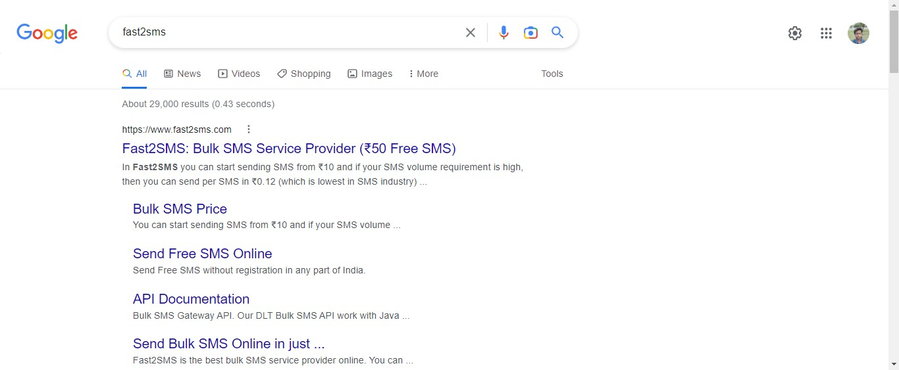

STEP-2:

Click on Sign up Now.

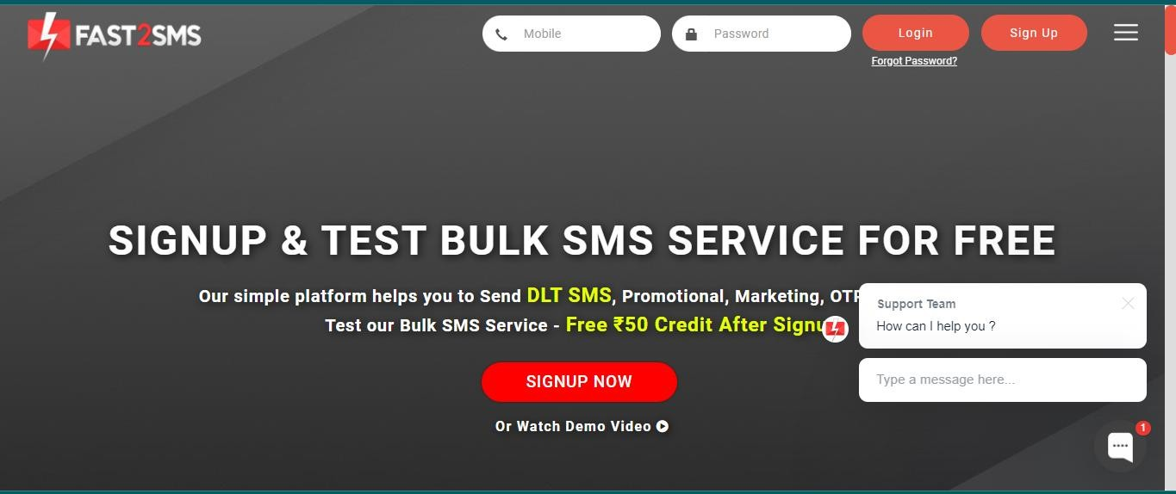

STEP-3

Give your details and click on the check box, then click the submit button.

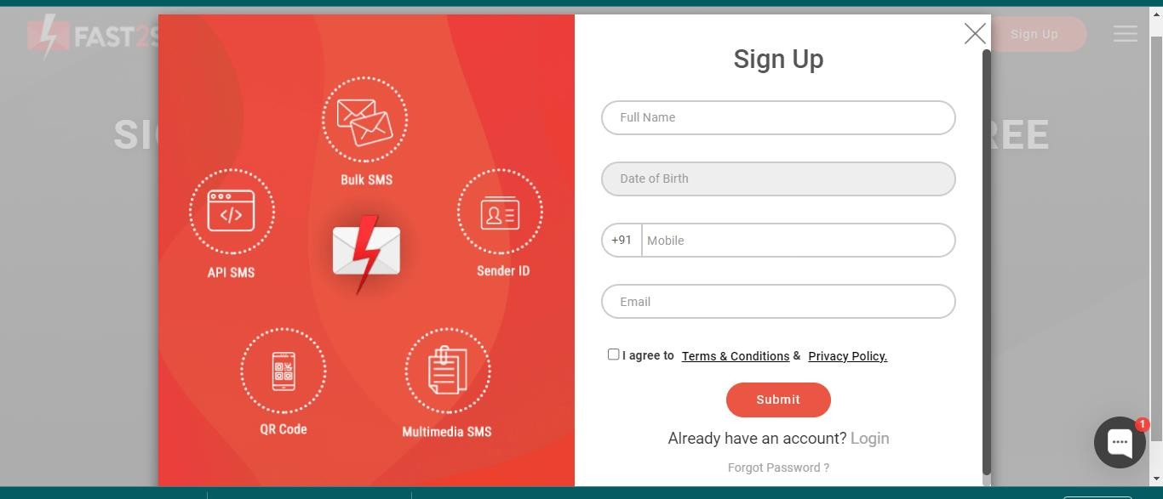

STEP-4:

You will get the SMS with your password. Type your mobile number and the password then click on the submit button

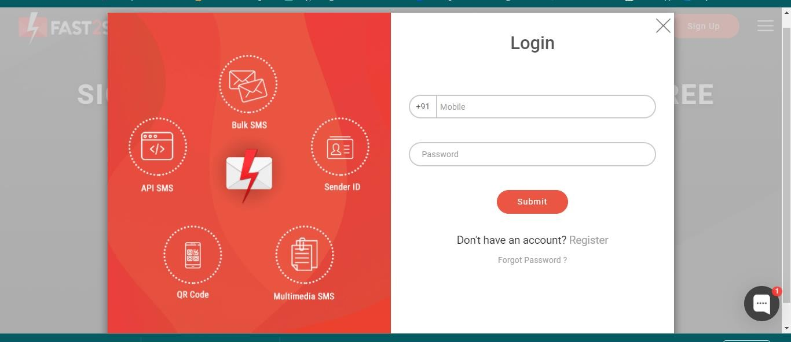

STEP-5:

Click on the Dev API

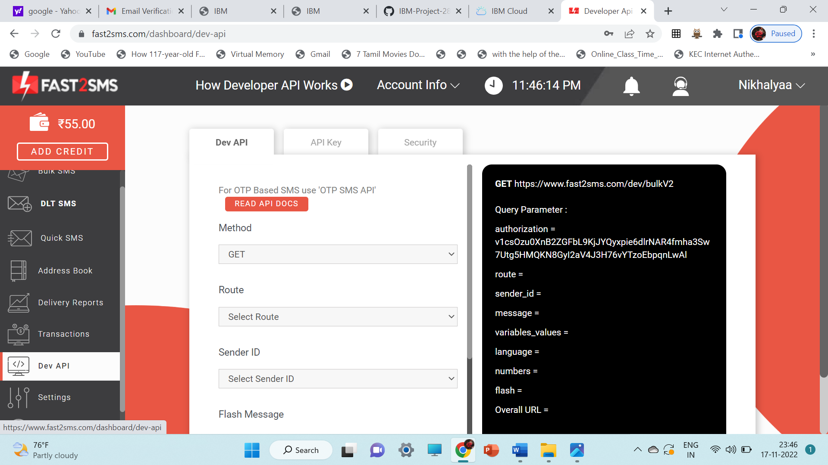

STEP-6:

Select the Route as quick SMS and type the message in Message box.

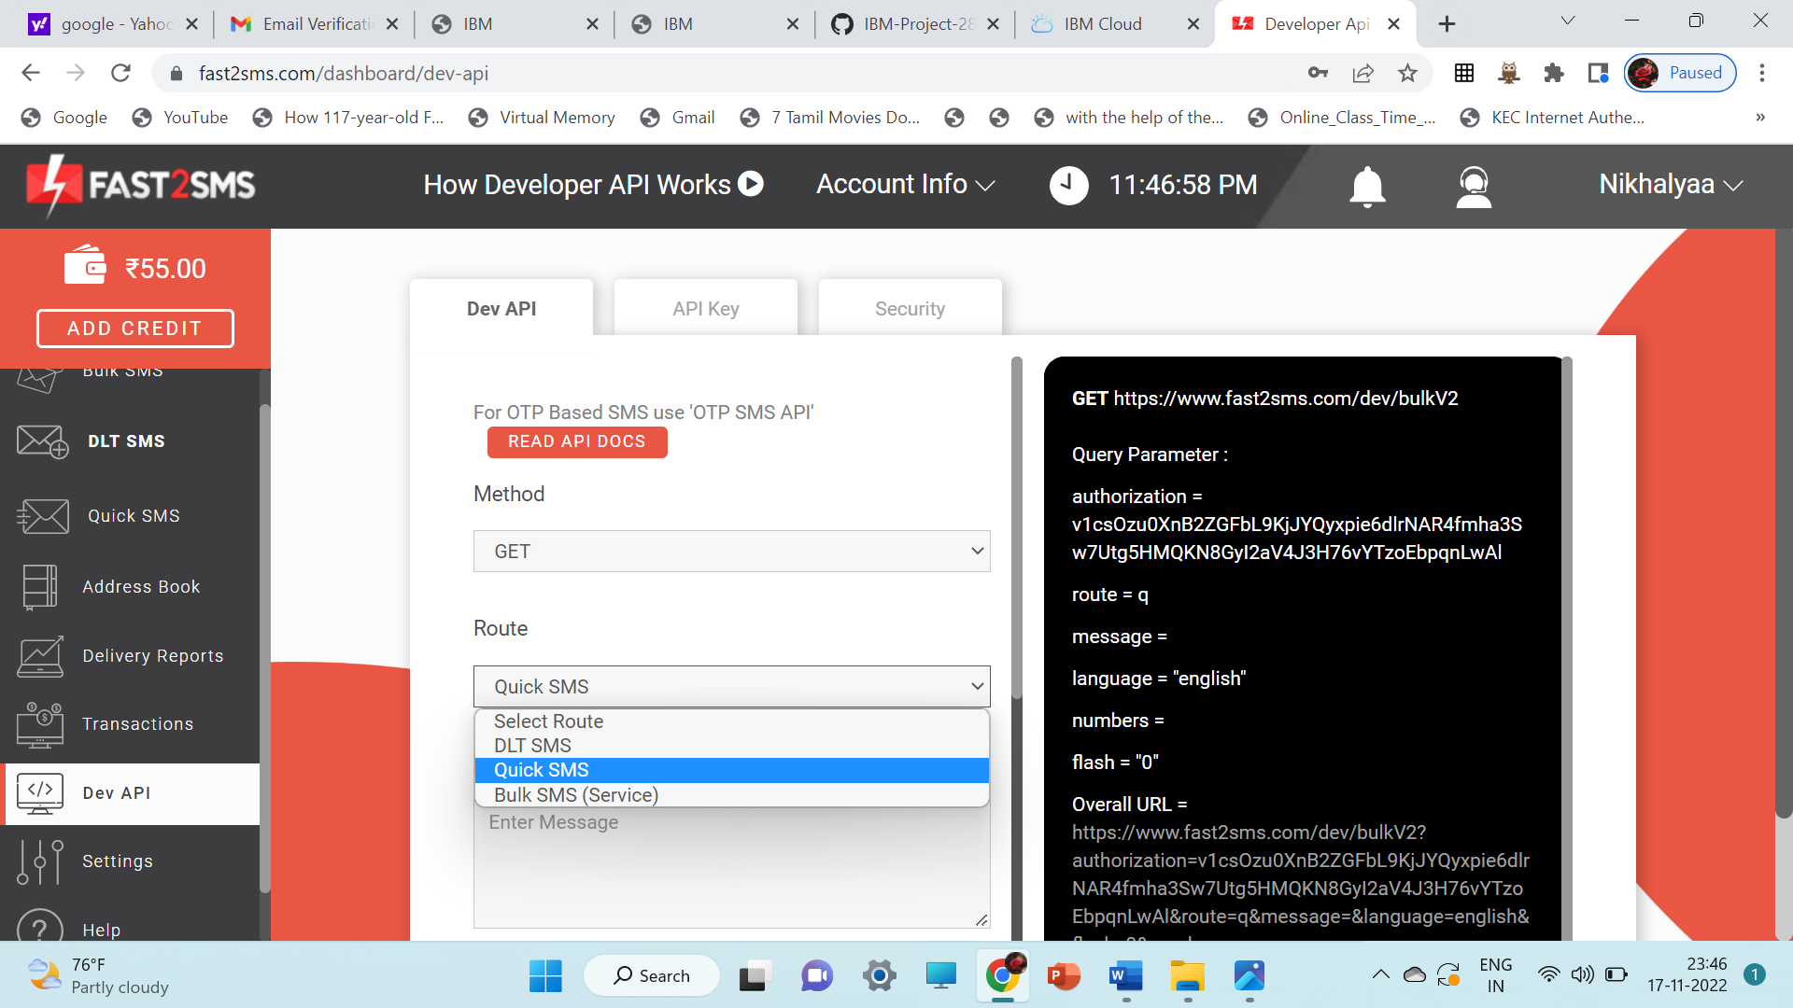

STEP-7:

Select your language and type your Mobile Number in Contact.

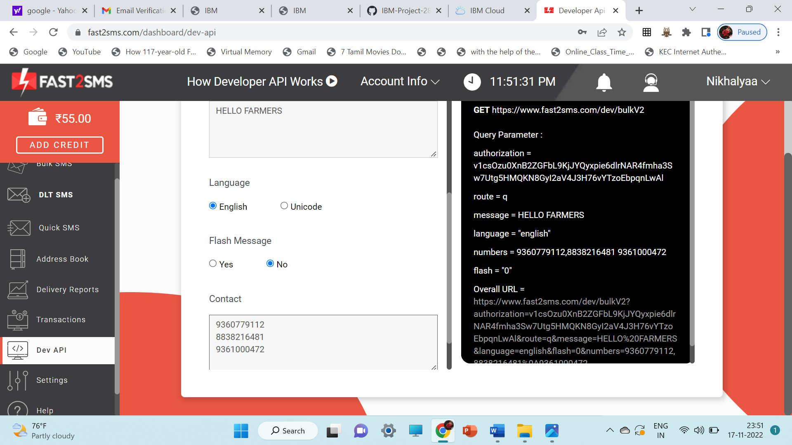

STEP-8

Copy the URL and paste it in the new tab.

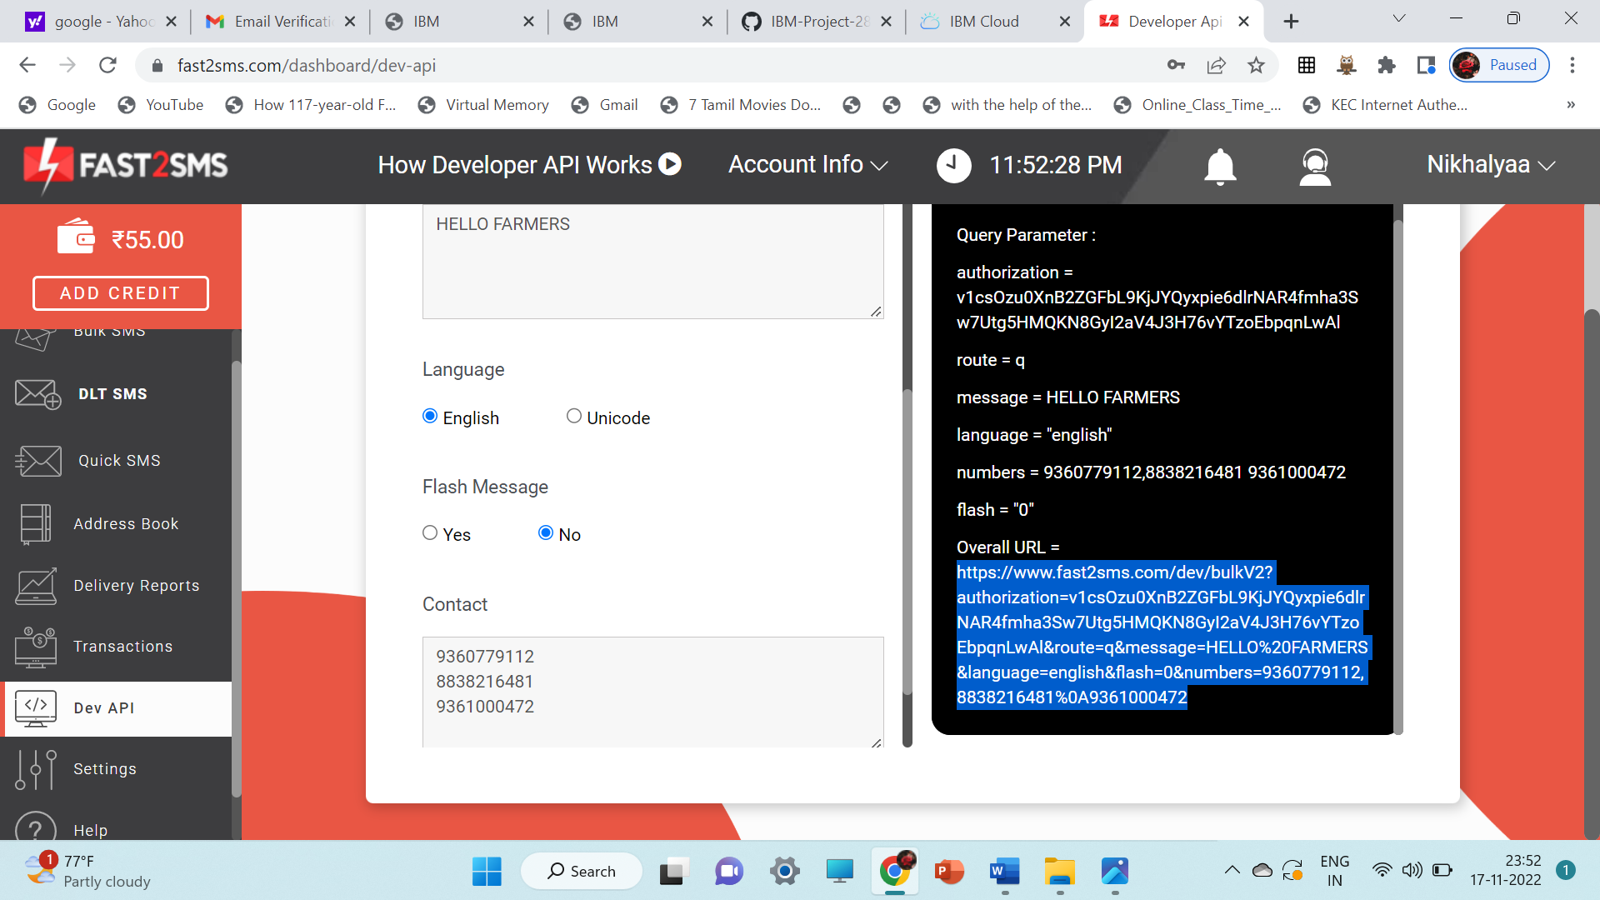

You will get the SMS in the new tab.

